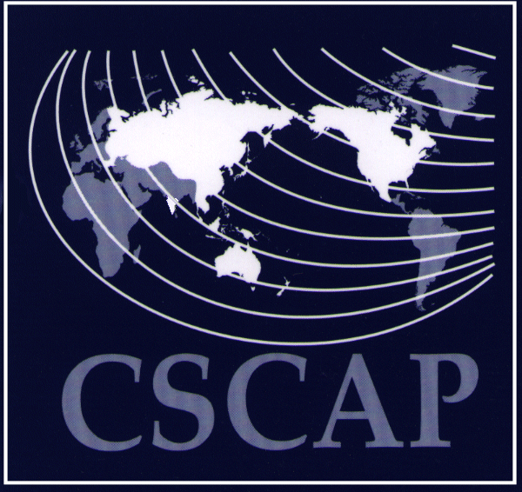
COUNCIL FOR SECURITY COOPERATION IN THE ASIA PACIFIC
30th CSCAP Steering Committee Meeting
Sofitel Silom Hotel, Bangkok
Thailand

GENERAL INFORMATION PAPER

- MEETING VENUE

Vendome Room (Level 36)
Sofitel Silom Hotel
188 Silom Road, Bangkok
Tel: +662-238-1991
Fax: +662-238-1999

- SECRETARIAT

The Secretariat will be at the Conference 3 (Level 36). We will be open at 1400-1900hrs on 21 January 2009; and at 0800-1700hrs on 22-23 January 2009.

- REGISTRATION

Participants may register at the Secretariat during its opening hours. Alternatively, you may also register at a counter located just outside the Conference 3 (Level 36) at 0800-0930hrs on 22 January.

- MEALS

- The welcoming dinner for participants of the Steering Committee Meeting will be held at The Retreat on 3rd Floor at 1830hrs on 22 January.

- Lunch on 22 January will be served at Mistral Restaurant at 1230-1400hrs while lunch on 23 January will be served at Shanghai38 Restaurant on 38th Floor at 1230-1330hrs.

- ACCOMMODATION

Reservations will be made for all foreign participants to stay at the Sofitel Silom Hotel Bangkok. The net room rate is US$151 per room per night (inclusive of daily buffet breakfast for one). In accordance with usual CSCAP practice, participants attending the Steering Committee meeting will be responsible for meeting the full costs of their own accommodation. Check-in time is after 12 noon check out time is at 12 noon. Participants who wish to arrive earlier or remain later should liaise directly with the hotel or inform the Secretariat well in advance.

- ATTIRE

- Smart casual for preliminary committee meetings.

- Business attire for the Steering Committee Meeting.

- Smart casual for the discussion sessions

- TRANSPORTATION

Participants may request for a hotel-arranged limousine service for transfers from the Bangkok International Airport to the hotel and back. Please contact CSCAP Thailand and provide your flight detail. The service will cost THB2000 (US$60) each way. The journey should take about 1hour. (Depended on traffic)

Alternatively, you may wish to take the airport taxi service which is cheaper than the hotel limo. A one-way fare is THB900 (US$30). A map is provided below along with instruction in English and Thai for guiding the taxi to the hotel.

From the main airport to the hotel take the tollway and then take the Ding Daeng exit. Get onto the expressway and follow the sign to Silom Road. Take exit for Silom Road, turn left onto Silom Road and continue along passing through 2 intersections, Surasak and Decho respectively. The hotel is on the left hand side of Silom Road.

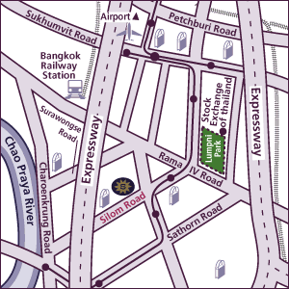

For Taxi

โรงแรม โซฟีเทล สีลม
ถนนสีลม ผ่านแยกสุรศักดิ์ และ แยกเดโช
โรงแรมอยู่ก่อนถึงแยกนาราธิวาสฯ

ที่อยู่ 188 ถ.สีลม เขตบางรัก
โทร 02.238.1991

- AIRPORT TAX

For international flights, the airport departure tax is included in the airfare.

- VISA REQUIREMENTS

Your passport should have a validity period of at least 6 months beyond the time of stay allowed in Thailand. You may require a visa prior to your arrival in Thailand. For information on visa requirements, please go to the Thai Ministry of Foreign Affairs website at http://www.mfa.go.th/web/2637.php

- FURTHER INFORMATION

Should you require further information, please contact the CSCAP Secretariat at ISIS Malaysia, email: cscap@isis.org.my, telephone: +603-2693 9366 Ext 129, Fax: +603-2693 9375. Please note that we will be at Conference 3 (Level 36), Sofitel Silom Hotel Bangkok, on 21 – 23 January 2009.

