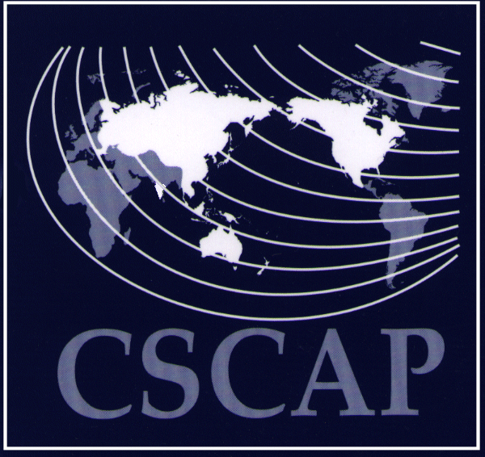
32nd CSCAP STEERING COMMITTEE MEETING
Grand Hyatt Hotel, Jakarta, Indonesia
15–16 November 2009
REGISTRATION FORM

PERSONAL DETAILS
Name:
Name: | Title | First/Given Name |  |  | Last/Family Name
Member Committee:
Designation:
Institution:
Office Address:
Telephone: |  |  | Fax:
Email:
HOTEL ACCOMMODATION
Check-in:
Check-in: | Date |  | Approximate Time
Check-out:
Check-out: | Date |  | Approximate Time
WELCOMING RECEPTION AT 1830HRS ON 15 November 2009
Yes, I will attend No, I will not be attending
REMARKS (IF ANY)

Accommodation
Reservations will be made for all foreign participants to stay at the Grand Hyatt Hotel, Bangkok. The net room rate is USD 121 net per room per night (inclusive of daily buffet breakfast for one). In accordance with usual CSCAP practice, participants attending the Steering Committee meeting will be responsible for meeting the full costs of their own accommodation.

We would appreciate your prompt return of this registration form by email or fax by 1 November 2009.

CSCAP Secretariat
Email: cscap@isis.org.my
Fax: +603-2693 9375

CSCAP Indonesia
Email: cscap_indonesia@csis.or.id
Fax: +66.2.254.0119

