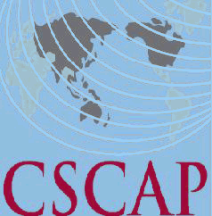
Council for Security Cooperation in the Asia Pacific
43rd CSCAP Steering Committee Meeting
June 3-4, 2015
Kuala Lumpur, Malaysia

REGISTRATION FORM

PERSONAL DETAILS

CSCAP Member Committee

Name:
CSCAP Member Committee  Name: | Title | First/Given Name |  |  | Last/Family Name
Title:
Institution:
Office Address:
City: |  |  | Country:
Phone: |  |  | Fax:
Email:

FLIGHT DETAILS

Arrival:
Arrival: | Date | Flight No. | Arrival Time
Departure:
Departure: | Date | Flight No. | Departure Time

HOTEL ACCOMMODATION
Date Check-In: |  | Date Check-Out:
Total nights:

In accordance with usual CSCAP practice, participants attending the Steering Committee meeting will be responsible for meeting the full costs of their own accommodation.
Welcoming Dinner (1900hrs, 3 June 2015) Attendance YES____ NO_____
Please indicate if you need a visa YES____ NO_____ and the location (city) of the embassy/consulate where you will obtain your visa:

Please send completed registration form (it’s compulsory to fill in all details)
By May 29, 2015 to Mr. Woo Hon Weng at CSCAP Secretariat via email cscap@isis.org.my
AND also copy to Ms. Murni Suranti and Ms. Nur Atikah via email
murni@isis.org.my and atikah@isis.org.my
Thank you.

