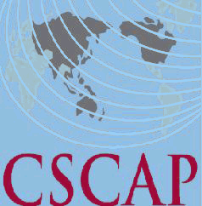
Council for Security Cooperation in the Asia Pacific
44th CSCAP Steering Committee Meeting
20-21 October 2015
Ulaanbaatar, Mongolia

REGISTRATION FORM

PERSONAL DETAILS

CSCAP Member Committee

Name:
CSCAP Member Committee  Name: | Title | First/Given Name |  |  | Last/Family Name
Title:
Institution:
Office Address:
City: |  |  | Country:
Phone: |  |  | Fax:
Email:

FLIGHT DETAILS

Arrival:
Arrival: | Date | Flight No. | Arrival Time
Departure:
Departure: | Date | Flight No. | Departure Time

HOTEL ACCOMMODATION
Date Check-In: |  | Date Check-Out:
Total nights:

In accordance with usual CSCAP practice, participants attending the Steering Committee meeting will be responsible for meeting the full costs of their own accommodation.
Welcoming Dinner (1900hrs, 20 October 2015) Attendance YES____ NO_____
Please indicate if you need a visa YES____ NO_____ and the location (city) of the embassy/consulate where you will obtain your visa:

Please send completed registration form (it’s compulsory to fill in all details)
By 13 October 2015 to Mr. Battulga Odgerel at CSCAP Mongolia Secretariat at
Email: battulga@issmon.mn or by Fax at +976-11-324055
AND also a copy to Mr. Woo Hon Weng at CSCAP Secretariat at
Email: phelanwu@isis.org.my, cscap@isis.org.my
Thank you.

