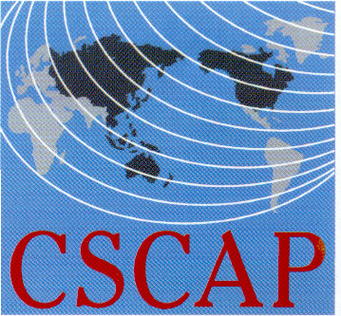
CSCAP Korea, CSCAP Malaysia & CSCAP Cambodia
Enhancing Contributions from Asia Pacific Countries to
UN Peacekeeping Operations

Somerset Palace Hotel, Seoul, November 11-12, 2016

REGISTRATION FORM (CSCAP)

PERSONAL DETAILS

CSCAP Member Committee

Name:
CSCAP Member Committee  Name: | Title | First/Given Name |  |  | Last/Family Name
Position:
Institution:
Office Address:
City: |  |  | Country
Phone: |  |  | Fax:
Email:

FLIGHT DETAILS

Arrival:
Arrival: | Date | Flight No. | Arrival Time
Departure:
Departure: | Date | Flight No. | Departure Time

HOTEL ACCOMMODATION
Date Check-In: |  | Date Check-Out:
Total nights:
I agree to pay the prevailing accommodation rates to cover my accommodation YES____ NO____

Welcoming Dinner (18:30pm, November 10th, 2016) Attendance: YES ______ NO______

Dietary Restrictions (if any) ____________________________________________

Optional Program: International PKO Conference (09:00-17:00, Nov 10th) Attendance: YES _____ NO_____

Important! Please indicate if you need a visa YES____ NO_____ and the location (city) of the embassy/consulate where you will obtain your visa: _________
Please send completed registration forms (it’s compulsory to fill in all details)
By October 26, 2016 to CSCAP Korea at Email: hyunjin.khu@gmail.com. Thank you.

