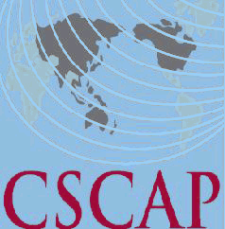
Council for Security Cooperation in the Asia Pacific
SECOND MEETING OF THE CSCAP STUDY GROUP ON
ENHANCING CONTRIBUTIONS FROM ASIA PACIFIC COUNTRIES
TO UN PEACEKEEPING OPERATIONS (PKO)
18-19 May 2017
Kuala Lumpur, Malaysia

REGISTRATION FORM

PERSONAL DETAILS

CSCAP Member Committee

Name:
CSCAP Member Committee  Name: | Title | First/Given Name |  |  | Last/Family Name
Position:
Institution:
Office Address:
City: |  |  | Country:
Phone: |  |  | Fax:
Email:

FLIGHT DETAILS

Arrival:
Arrival: | Date | Flight No. | Arrival Time
Departure:
Departure: | Date | Flight No. | Departure Time

HOTEL ACCOMMODATION
Date Check-In: |  | Date Check-Out:
Total nights:

I have been designated by my CSCAP committee to avail of the one free hotel accommodation per committee. YES_____ NO_____

Welcoming Dinner (1830hrs, 17 May 2017) Attendance YES_____ NO_____
Dietary Restrictions (if any) ____________________________________________
Important! Please indicate if you need a visa YES____ NO_____ and the location (city) of the embassy/consulate where you will obtain your visa: _________________________________

Please send completed registration form (it’s compulsory to fill in all details)
By Wednesday, 3 May 2017 to MIMA’s Ms. Nor Izwani and Mr. Mohd Ikmal Hisyam via
Email: izwani@mima.gov.my and ikmal@mima.gov.my
AND also a copy to Mr. Woo Hon Weng at CSCAP Malaysia via
Email: phelanwu@isis.org.my. Thank you.

