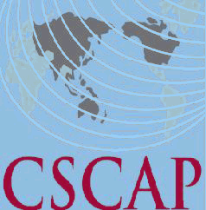
Council for Security Cooperation in the Asia Pacific
FINAL MEETING OF THE CSCAP STUDY GROUP ON
ENHANCING CONTRIBUTIONS FROM ASIA PACIFIC COUNTRIES
TO UN PEACEKEEPING OPERATIONS (PKO)
20-21 Nov 2017
Siem Reap, Cambodia

REGISTRATION FORM

PERSONAL DETAILS

CSCAP Member Committee

Name:
CSCAP Member Committee  Name: | Ms.
CSCAP Member Committee  Name: | Title | First/Given Name |  |  | Last/Family Name
Position:
Institution:
Office Address:
City: |  |  | Country:
Phone: |  |  | Fax:
Email:

FLIGHT DETAILS

Arrival:
Arrival: | Date | Flight No. | Arrival Time
Departure:
Departure: | Date | Flight No. | Departure Time

HOTEL ACCOMMODATION
Date Check-In: |  | Date Check-Out:
Total nights:

I have been designated by my CSCAP committee to avail of the one free hotel accommodation per committee. YES_____ NO____

Welcoming Dinner (1830hrs, 19 Nov 2017) Attendance YES_____ NO____
Dietary Restrictions (if any) ____________________________________________
Important! Please indicate if you need a visa YES____ NO____ and the location (city) of the embassy/consulate where you will obtain your visa: _________________________________

Please send completed registration form (it’s compulsory to fill in all details)
By 1 November, 2017 to CICP’s Ms. Neth Chantha via
Email: cicp01@online.com.kh;
AND also a copy to CSCAP Secretariat via
Email: cscap@isis.org.my. Thank you.

