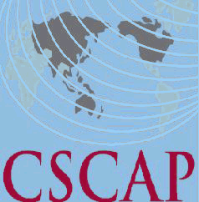
Council for Security Cooperation in the Asia Pacific
47th CSCAP Steering Committee Meeting
May 24-25, 2017
Kuala Lumpur, Malaysia

REGISTRATION FORM

PERSONAL DETAILS

CSCAP Member Committee

Name:
CSCAP Member Committee  Name: | Title | First/Given Name |  |  | Last/Family Name
Title:
Institution:
Office Address:
City: |  |  | Country:
Phone: |  |  | Fax:
Email:

FLIGHT DETAILS

Arrival:
Arrival: | Date | Flight No. | Arrival Time
Departure:
Departure: | Date | Flight No. | Departure Time

HOTEL ACCOMMODATION
Date Check-In: |  | Date Check-Out:
Total nights:

In accordance with usual CSCAP practice, participants attending the Steering Committee meeting will be responsible for meeting the full costs of their own accommodation.
Welcoming Dinner (2000hrs, 24 May 2017) Attendance YES____ NO_____
Please indicate if you need a visa YES____ NO_____ and the location (city) of the embassy/consulate where you will obtain your visa:

Please send completed registration form (it’s compulsory to fill in all details)
By May 3, 2017 to Mr. Woo Hon Weng at CSCAP Secretariat via email
phelanwu@isis.org.my AND also copy to Ms. Maria Aziz and Ms. Nur Atikah Ishak
at ISIS Malaysia via email maria@isis.org.my and atikah@isis.org.my
Thank you.

